Lab5 Raspberry pi and ARDUino

Computer Systems Fundamentals, 2016-17 SEM1

Name: Jamie Geddes

Email address: Jamie.geddes@yorksj.ac.uk

**Contents**

Task1

Task2

Task3

Task4

Task5

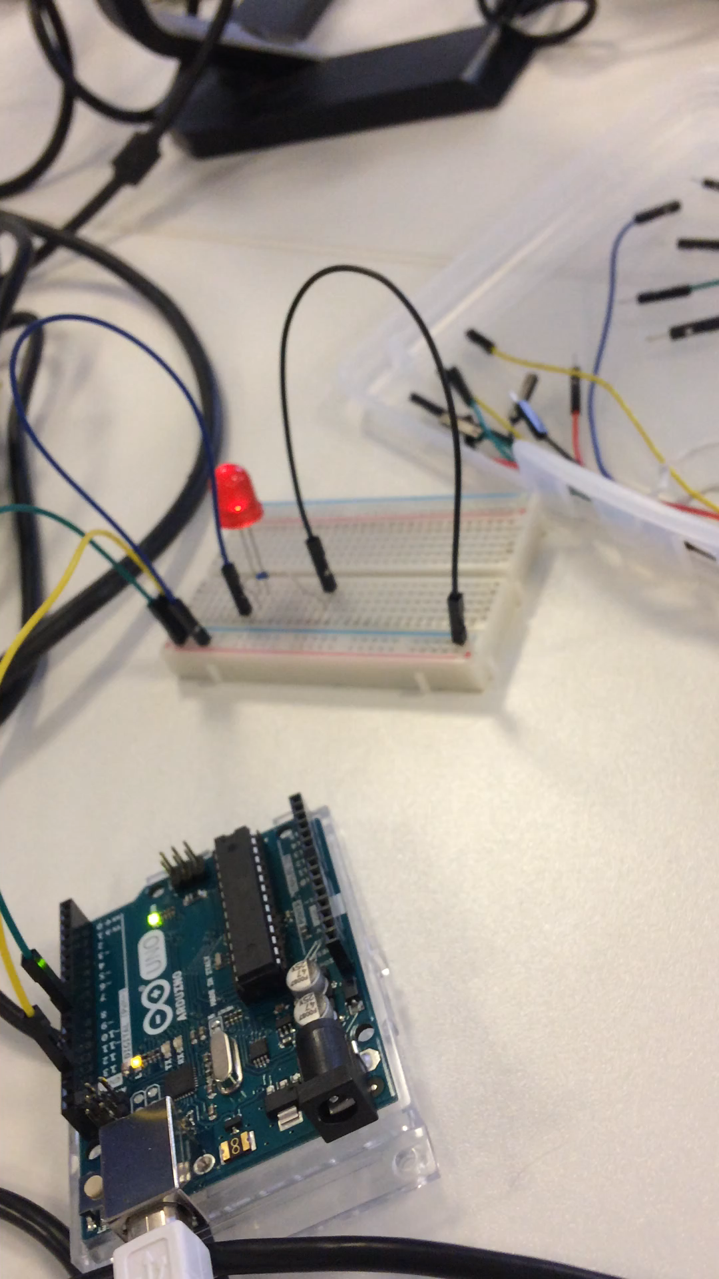**Task 1** light slowly brighten.

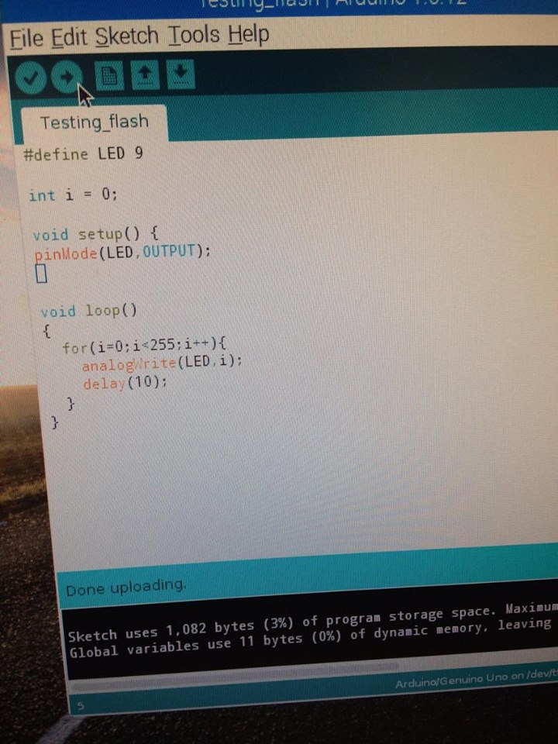

Above is the code which was used to make the LED slowly brighten up.

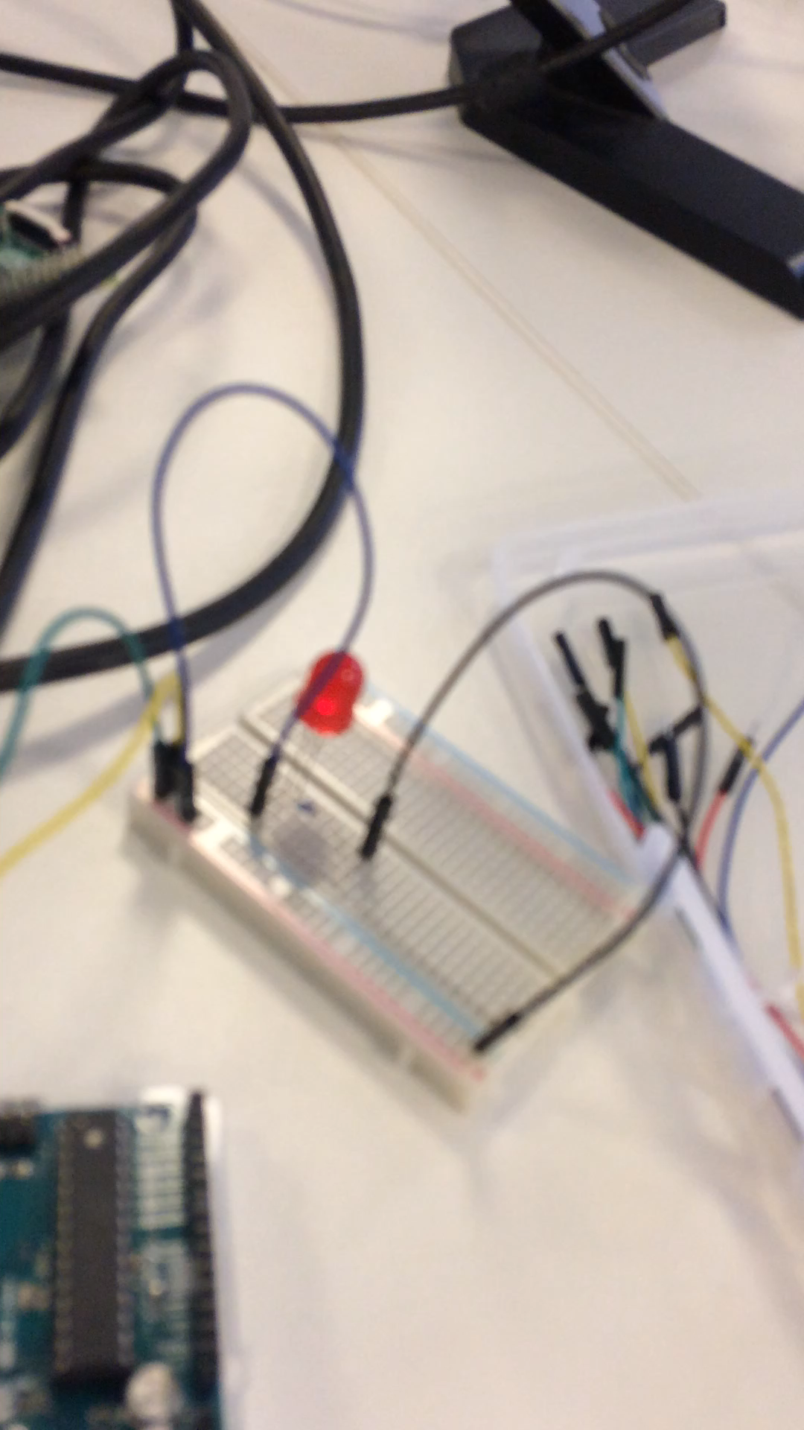**Task 2**

Can you modify it so that it phases down as well.

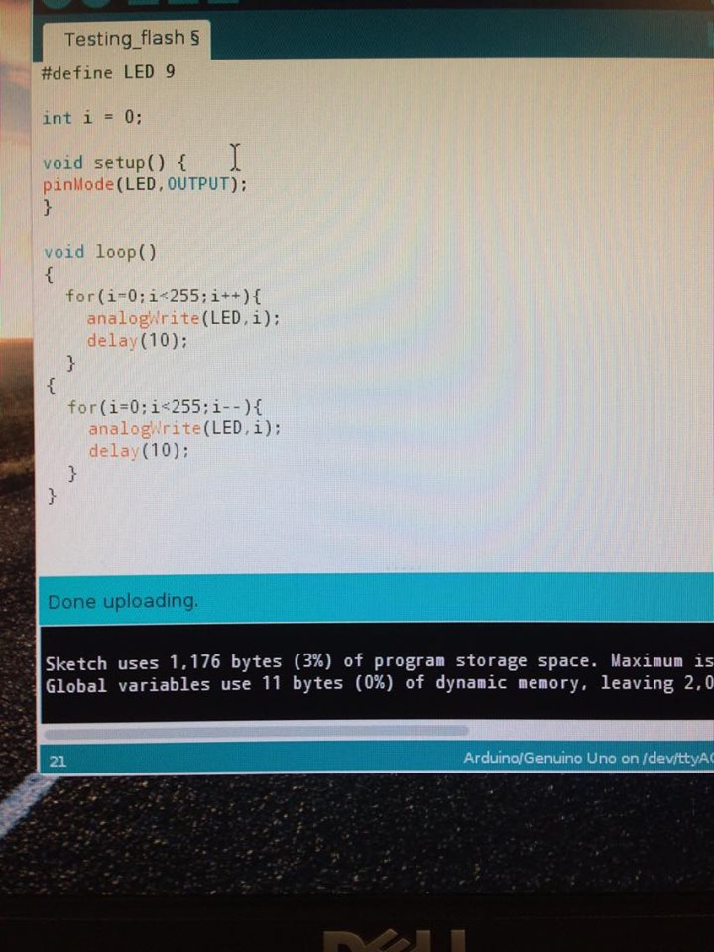

Above is the code which was used to make the light phase down, all I did was add another for loop and changed the i++ to i--.

**Task 3**

Analog Input Light sensor

Below shows an image of all the code used and a video of the light sensor working and how it changes when becomes bright enough.

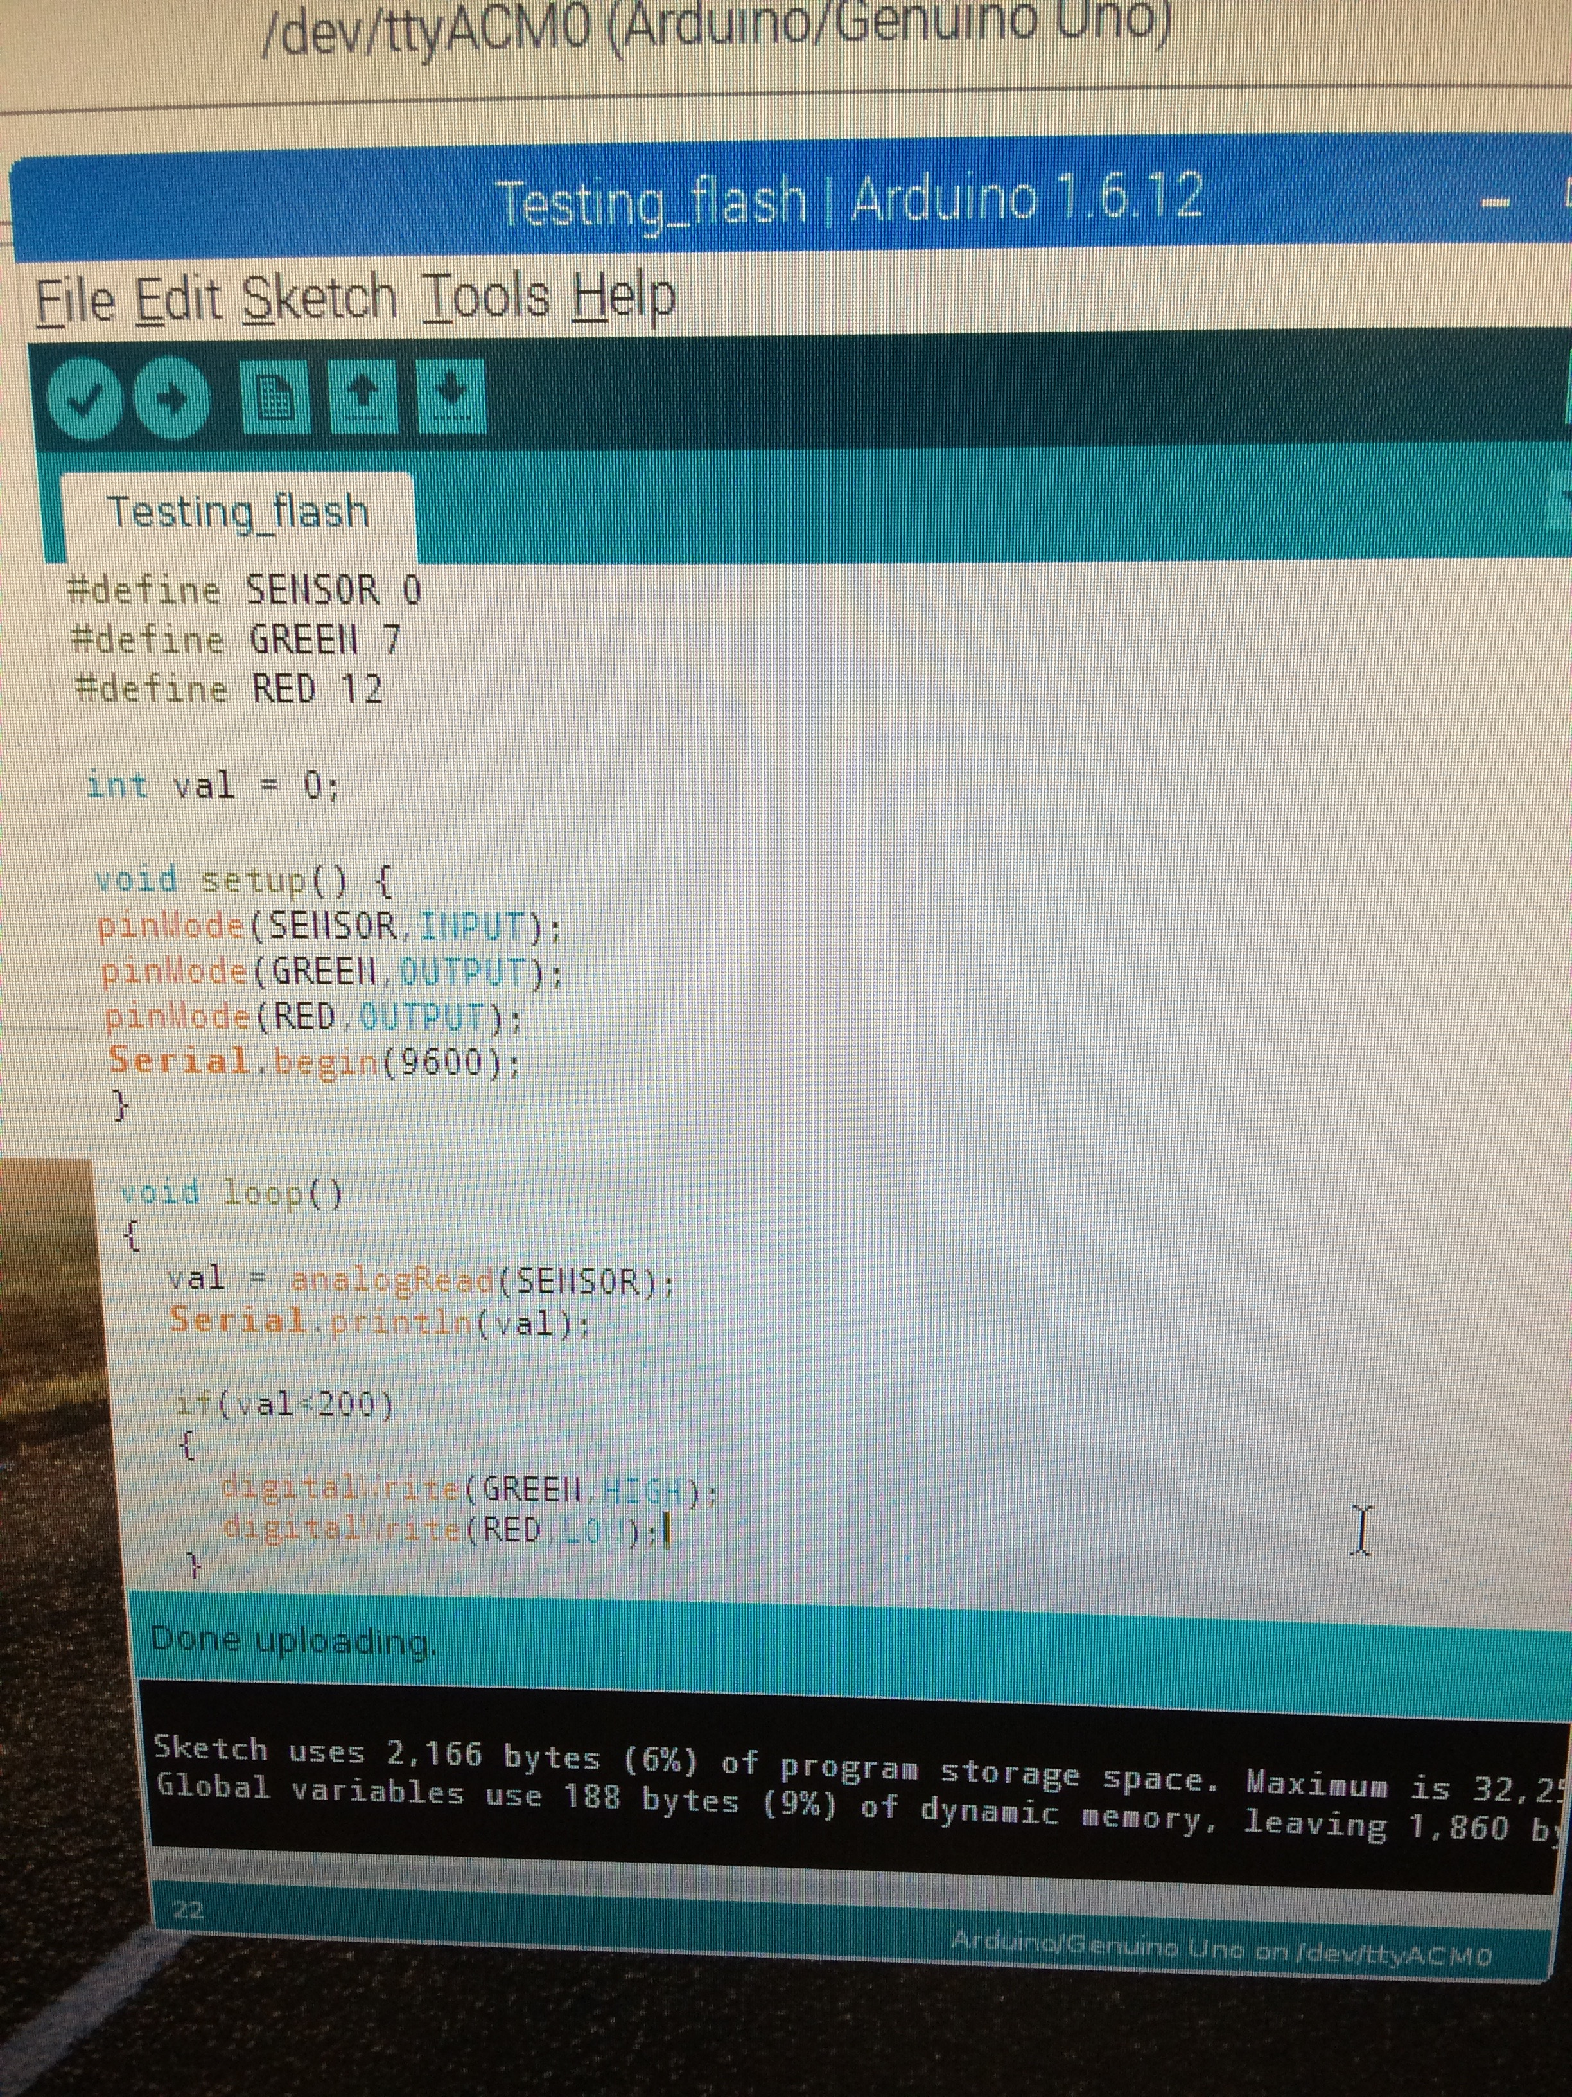

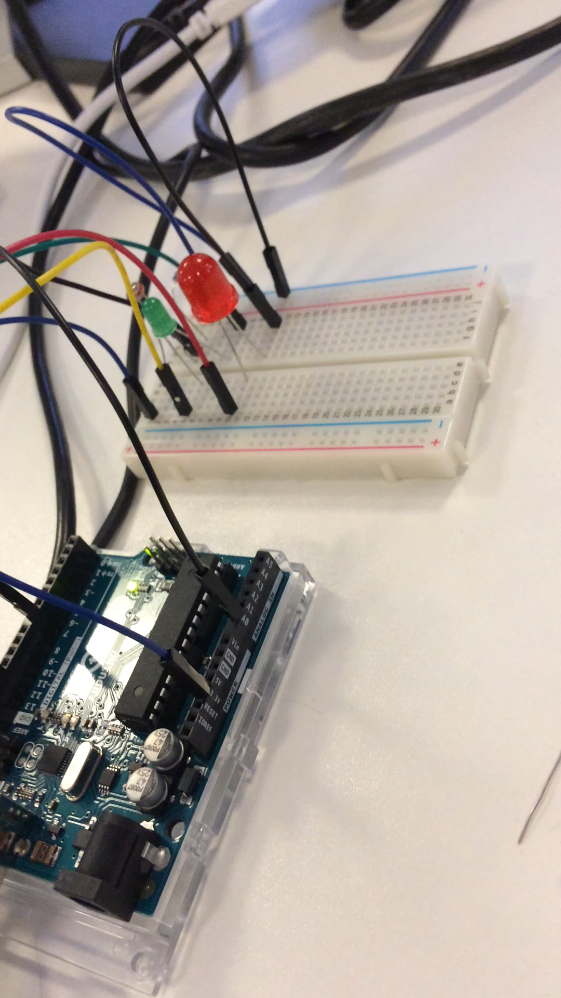

## Task4

## Connect the Pi and Arduino via the usb and use the connection so that the Arduino talks to the Raspberry Pi

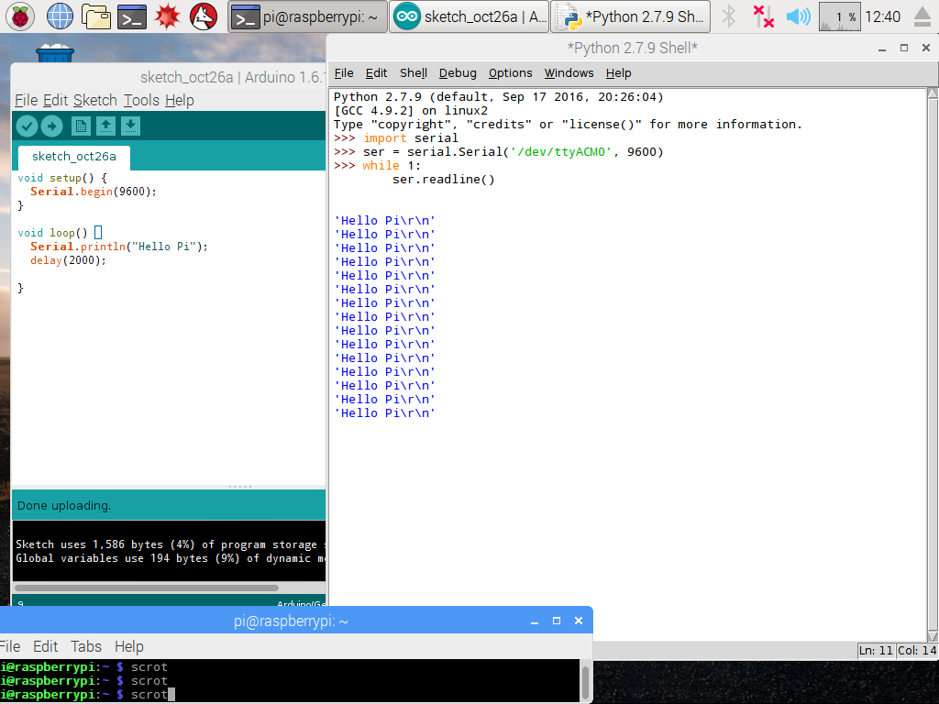

The image above clearly shows that Arduino is talking to the pi as it prints hello in the python shell.

**Task 5**

Raspberry Pi Sending Data To Arduino

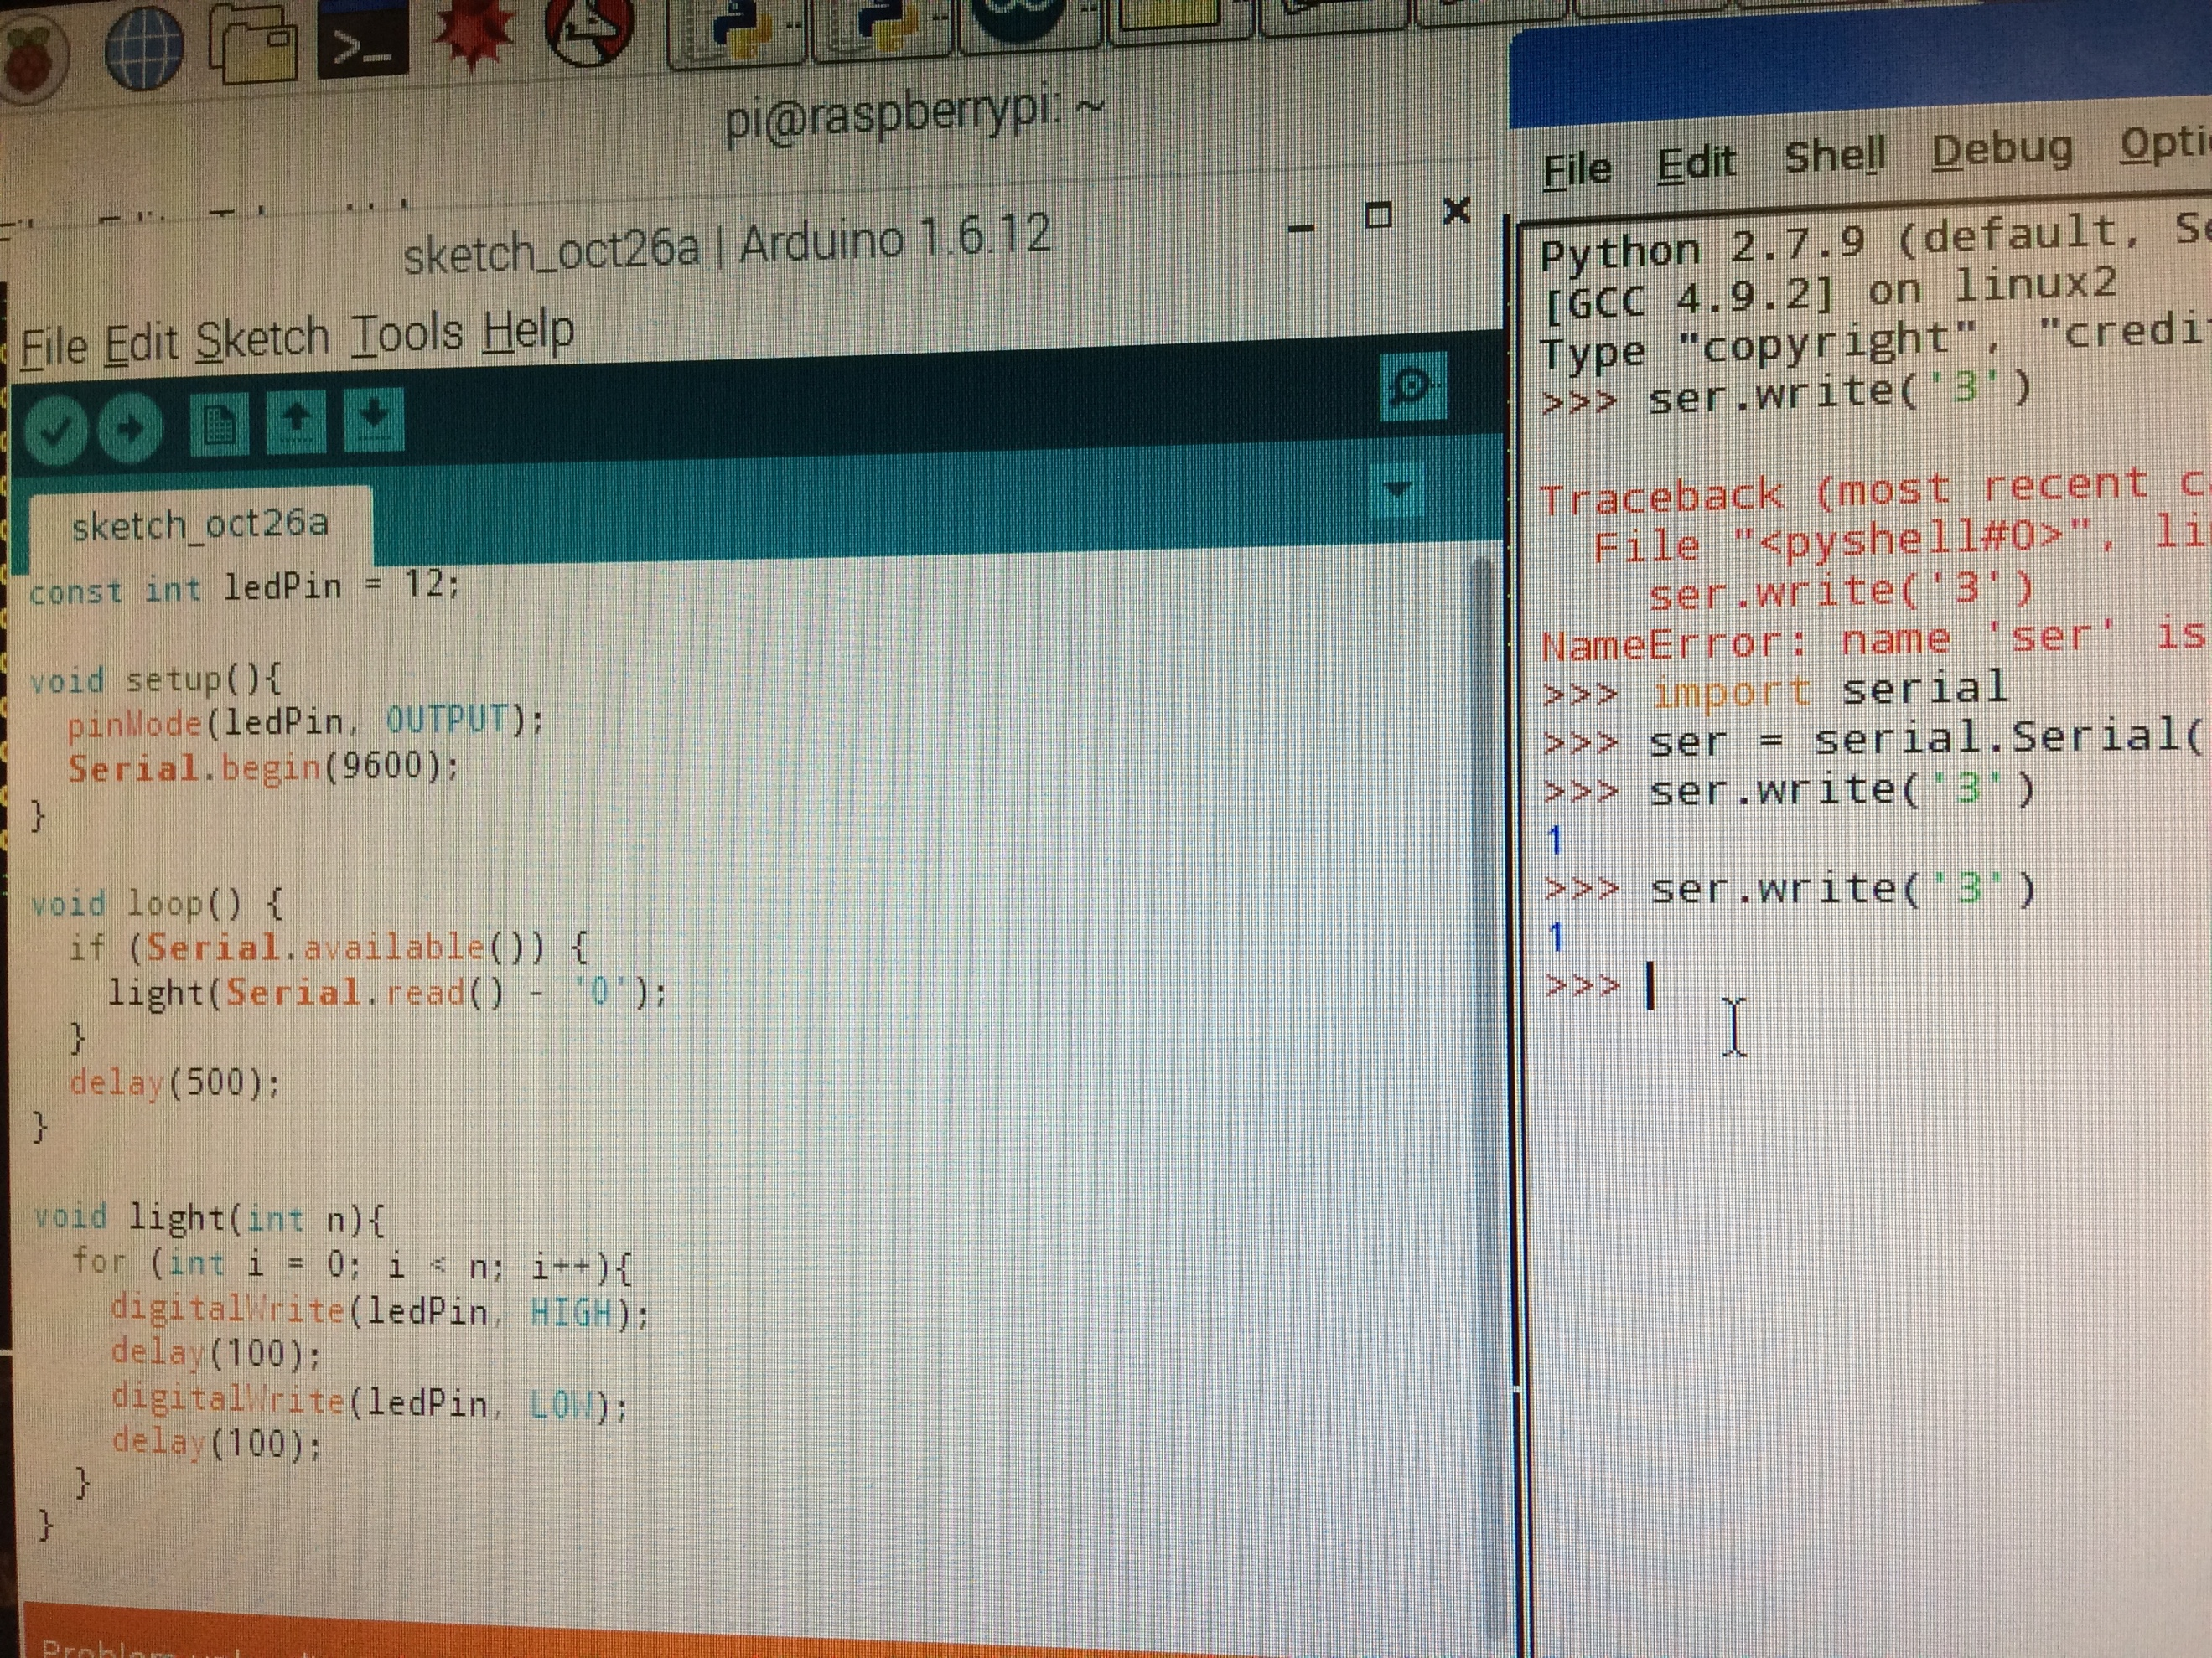

This image above shows me writing the code to make the raspberry pi send the data to the Arduino and the response is shown on the right with the indicator 1 showing that it worked.